Transformer based Bidirectional Translation Model for German-English Language pair.

Gaurav Airan  Post Grad Student in CS and AI  IIT-Delhi and Great Learning.  airangaurav8@gmail.com | Debadri Dutta  Post Grad Student in CS and AI  IIT-Delhi and Great Learning.  hackerearthps@gmail.com | Rahul Bhardwaj  Post Grad Student in CS and AI  IIT-Delhi and Great Learning.  Rahul798bhardwaj@gmail.com
Vivek Kumar  Post Grad Student in CS and AI  IIT-Delhi and Great Learning.  vivekmesuperb@gmail.com | Sandhiya U B  Post Grad Student in CS and AI  IIT-Delhi and Great Learning.  usandhiyab@gmail.com | Manikandan Anantharaj  Post Grad Student in CS and AI  IIT-Delhi and Great Learning.  Manikandan.a957@gmail.com

Abstract - This paper focuses on the development of a decent language translation model between German and English that falls in the domain of Natural Language Processing (NLP) and Deep Learning (DL). The primary objective is to design and implement a robust Neural machine translation model capable of translating text accurately and effectively in both directions. The proposed model leverages state-of-the-art techniques such as transformer models, encoder-decoder architecture and self-attention, along with significant exploration in areas of recurrent neural networks (RNN), LSTMs and Luong’s Attention mechanisms. To calculate the quality of translation, BLEU score is used as a metric. Model is trained and tested on Europarl database available for both the languages as open source. The outcome of this research provides a detailed look on the practical challenges that comes while building such a model and get accustomed with latest work done in the field. We were able to build the model successfully and achieved a decent BLUE score. A comparison is also done between the RNN based and Transformer based translation model.

Keywords – translation model, NLP, Transformer, Self-attention, Europarl, BLUE.

I. Introduction
The most extensive catalogue of the world’s different languages, generally taken to be as authoritative as any, is that of Ethnologue [1] (published by SIL International), whose detailed classified list as of 2009 included 6,909 distinct languages. According to the Census of India (2011) [2], there were 121 major languages in India with 1599 other languages due to India position on silk route and ancient language link between Indo-Greek-German influence. Learning every language for all humans is definitely an impossible task. Thus arises a need of an automated translator that can help connect overcoming linguistic barriers.
Neural Machine Translation (NMT) is the task of translating one natural language into the other without changing the meaning of the input text and producing a meaningful text in the output language. And this is done with the help of a Neural Network trained via Deep Learning algorithms. NLP is an intersection of fields in Linguistics and Computer Science. It is related to building smart computer systems to understand, analyse and process languages, based on understanding of phenomenon and human perception of that language, to produce desired outcomes like Translation, Sentimental analysis.
This paper presents a working German-English translator which can do automatic language translations. The translator is bidirectional i.e., capable of translation both ways. The main model uses Transformers as building blocks which works on Encoder-Decoder architecture and self-attention mechanism.

II. Literature Survey
A. History
Although the history of Language Translation can be traced back to as early as 196 BCE Rosetta Stone [3], a single stone inscribed with three different texts in Ancient Egyptian and Greek languages, we will try to focus on the brief history of Machine Translation, when the idea of computers to do translations started evolving.
The very first idea of “machine” translation is credited to be given by French Engineer George Arstrouni in 1932 is to develop a multilingual mechanical dictionary and a multipurpose “Mechanical Brain” which will be capable of translating languages of different nations into each other.
In the 1950s and 1960s research under Erwin Reifler at the University of Washington formed the word-for-word approach. In 1964 the government sponsors of MT in the United States formed the Automatic Language Processing Advisory Committee (ALPAC) which provided a report in 1966 concluding that MT was slower, less accurate and twice as expensive as human translation and that 'there is no immediate or predictable prospect of useful machine translation'. At Montreal, research began in 1970 on a syntactic transfer system for English-French translation. a group from IBM published in 1988 the results of experiments on a system based purely on statistical methods. What surprised most researchers (particularly those involved in rule-based approaches) was that the results were so acceptable, almost half the phrases translated either matched exactly the translations in the corpus, or expressed the same sense in slightly different words. Works of Hutchins [4] and Poibeau [5] can be referred for detailed historical context of Machine Translation.
Slocum et al. [6] has given a very nice historical perspective of defunct systems in the field of MT. Some to mention are Georgetown’s GAT from 1952 which was developed for translating Russian texts to English under the support of US government but didn’t provide good output quality, Texas’s METAL for German to English MT in 1956 which was funded by US government and Brigham Young University’s ALP system from 1973 which was established to translate Mormon ecclesiastical texts from English into multiple European languages and emphasized on Machine aided translation.

B. Challenges
Machine Translation is not an easy task, just because of the sheer amount of ambiguity and diversity in all the languages. Koehn P and Knowles R [7] has described six challenges related to Neural Machine Translation: Lower Adequacy, Insufficient training data, low-frequency words from highly-inflected categories like verbs, long sentences, possible divergence by Attention models for word alignment and Beam search decoding. There is another challenge which is less interpretability of NMT models.
Zhang and Zong [8] have defined that in NMT formulation, sentence is the basic input for modelling. However, some words in the sentence are ambiguous and the sense can only be disambiguated with the context of surrounding sentences or paragraphs. And when translating a document, we need to guarantee the same terms in different sentences lead to the same translation while performing translation sentence by sentence independently cannot achieve this goal. In a word, sentence-level translation will harm the coherence and cohesion of the translated documents if we ignore the discourse connections and relations between sentences. Other common challenges are there may be rare words in the sentence, different language have different syntax.
Apart from generic challenges, there may be special challenges for different language pairs. For example, Use of Kanji in Japanese requires different NMT model architecture, consisting of CNN layers, for the identification of symbols. As our project deals with German-English pair, there are some challenges specific to this pair also. Popovic, Stein and Ney [9] have elaborately discussed about special challenges related to German Compound words to Statistical Machine Translation. Compounding in German means combining several words together to create a new word. Based on simple Permutation, this can increase the vocabulary size drastically. Their paper used a combination of techniques, like splitting and re-joining German compounds and accordingly joining English components as well as performing word alignments based on the splitting point of compound words to improve the translation quality. Koehn [7] proposed the splitting based on Corpus, rather than linguistic, for the same compounding problem.

C. Methods and Techniques
There are three main subtypes of Machine Translation- Rule Based, Statistical and Neural. Rule-based is not used anymore now, as it requires specific rule formulations for both the source and target languages based on linguistic information.
Statistical Machine Translation (SMT) [10] doesn’t need any human defined rules, rather it requires vast amount of translated data in both the languages. SMT models attempts to create hypothesis based on the patterns it identifies on analyzing the existing translated data. This hypothesis is then used for fresh translation of new phrases. The ideas of STM were first given by W Weaver in the late 1950s. IBM Research is developed one of the first successful SMT machines in early 1990s that didn’t require any example or rule-based information. Quality deteriorates as sentences gets longer or ambiguity in texts increases as we move away from technical or scientific texts.
Concept of Neural Machine Translation was first introduced by works of Kalchbrenner and Blunsom [11] in 2013. They proposed 2 Recurrent Continuous Translation models- RCTM 1 and RCTM 2 which, based on probability distribution over the source language sentences, determines the target sentence. The two models differ in the sense that first one uses Convolutional Sentence Model (CSM) while second one uses n-gram CSM.
Unlike the Statistical MT, which evaluates on small phrases of sentences for translation and rejoining later, Neural MT creates a vast Neural Network by training on the given corpus, and provides a single target language output for the source language full input sentence. Google switches from phrase-based SMT to GNMT system (Google Neural Machine Translation) [12] in 2016, 10 years later of launching its first translation services in public domain.
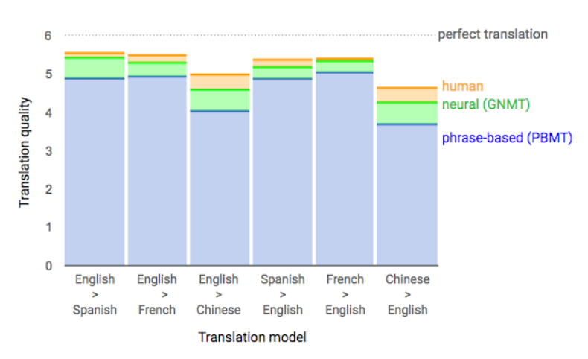
Figure 1 Quality of various NMT models as per Google AI blog.

Figure 1, taken from Google AI publication [13] in 2016, shows the better translation quality of Neural (GNMT) over phrase-based (PBMT) but still underperforms when compared to human translation quality. Score ranges from 0-6, 0 being “completely nonsense translation” and 6 meaning “perfect translation”.
The use of Attention mechanism for NMT draws its roots from the paper published by Bahadanu et al., 2014 [14]. They introduced an encoder-decoder model which can learn to align and translate jointly and gave very good results for translation of big sentences in single output. Idea was to get rid of fixed length vector to represent input sentence and rather predicting the relevant words at each step and provides than annotation and more weight.
Most of the proposed NMT early were based on a layered architecture of encoder-decoder, created using RNNs (Sutskever et al., 2014 [15]). Later, LSTM based NMT (Cho et al., 2014 [16]) was introduced. Vaswani et al., 2017 [17] presented their famous work on Transformers in “Attention is All You Need” publication at NIPS, which got rid of RNNs thus improving the computational speed of MT systems.

D. Latest Developments and Comparisons
Google scientists in 2013 released a paper [18] in which they presented their research on similarities among various languages and how to exploit them for Machine Translation. They conducted experiments on WMT11 Datasets [19] for similar language pairs like English and Czech and also on distant language pair of English-Vietnamese. The focus was on improving the dictionaries and phrase tables, which in-turn are used in MT to get good accuracy on short sentence translations. For creating dictionary and representing every word, they used Continuous Bag-of-Words and Skip-gram model [20]. Zhang and Liu [25] has proposed Paragraph-Parallel based NMT with hierarchical attention model to get context from word-level and clause-level abstractions in a structure and dynamic manner.
After Transformers, several new language representation models were created based on the similar technique.
Devlin et al, 2019 [21] introduces BERT (Bidirectional Encoder Representation of Transformers) which improved the accuracy of NMT by masking several words in the source sentence in pre-training phase. This helps overcome the unidirectionality constraint of self-attention, i.e., attending only previous tokens while evaluating current token in the sequence.
Zhu, Jinhua, et al., 2020 [22] conducted many experiments by creating various BERT-fused models for different language pairs. They proposed performing masking into all layers rather than serving on input embeddings only.
Phrase-based MT, although gives considerable performance as compared to very simplistic RNN model, is not very cost effective in terms of time complexity. Introducing Attention in RNN based models improved the score two times, which is massive improvement. GNMT, which is Google translator, has BLEU [23] score of 24.61 when input and output were fed in form of word pieces. Transformer and BERT were proved to be best performing models.
Table 1 is a comparison between difference EN-DE (English-German) Translation models that we have discussed so far.
S. No. | Model | Dataset | BLEU Score
1 | Phrase Based MT (Freitag et al.,2014) | WMT Test 2014 | 20.7
2 | RNN Enc-Dec (Luong et al., 2015) | WMT Test 2014 | 11.3
3 | RNN Enc-Dec Att(Chung el al., 2016) | WMT Test 2015 | 23.45
4 | GNMT word pieces (Wu et al.,2016) | WMT Test 2014 | 24.61
5 | Standard Transformer (Vaswani et al., 2017) | ISWLT 2014 | 28.57
6 | BERT- fused model (Zhu, Jinhua, et al., 2020) | ISWLT 2014 | 30.45
Table 1. BLEU score Comparison of various MT models.

III. Proposed Work
A. Data
We have selected version 7 of Europarl Corpus [24] to train the NMT model amongst other corpuses available like New Commentary or Common Crawl. The choice was made after doing a certain level of quality check on each database. The corpus provides text files in multiple languages, where each line is the translated version of corresponding line in other text files. For our model, we selected German (DE) and English (EN) files. Total lines present in each text file are 1.92 million, which provides about 50 million words of training data per language, alone from the Europarl corpus.
For initial insights, the average length of both English sentences and German sentences were compared as shown in Figure 2. Along with that the word distribution in sentences for each language was checked.
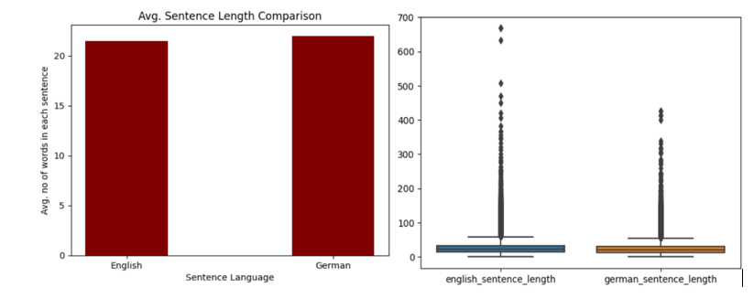
Figure 2 English- German sentence Length comparison
For our model, we chose first 500k sentences from Europarl dataset as raw database. Vocabulary was built for them. After that, we filtered out sentences of length less than or equal to 20 words. Ultimately, we had around 93k sentences on which our main model was trained. Target Vocabulary Size was parameterized as 6000. The encoded vocabulary was build using method SubwordTextEncoder imported from tensorflow_datasets package. The sentences shorter than 20 tokens were padded to match the length. After padding, the total dataset was divided into 64 Batches with proper shuffling.
B. Methods and Materials
For our base model, we use LSTM – a kind of RNN as building blocks for the model. This helped us understand the basic challenges with the pre-processing of data to prepare it for the Neural Network training. As the model uses Encoder-Decoder Architecture, we got familiar with these components and how to code them. Attention layer also makes a crucial part of this model. We studied on Luong’s as well as Cross attention mechanism and compared the performances.
RNN (Recurrent Neural Network) is a kind of Neural Networks that contains “Hidden” state to capture the sequence related information, thus makes it better at sequence data modelling. LSTM (Long Short-Term Memory) is an advanced kind of RNN, which contains “cell” state that allows it to remember past data in memory easily. This helps in overcome problems of vanishing and exploding gradient which RNN are prone to.
In encoder-decoder architecture (Figure 3), where the input sequence is first encoded into a fixed-length vector representation and then decoded into the output sequence. The encoder-decoder mechanism is a common approach for machine translation and has been shown to be effective in capturing the meaning of the input sentence and generating the corresponding translation. Attention is a mechanism that allows the model to selectively focus on certain parts of the input sequence while generating the corresponding output sequence. This mechanism has been shown to improve the performance of machine translation models, particularly for long sentences.
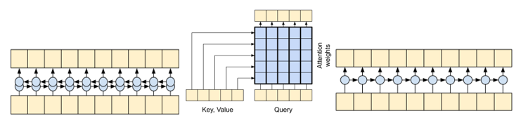
Figure 3 Encoder -> Attention -> Decoder Architecture.

For our Main model, we proposed to perform Transformer based NMT. In Machine Translation (MT), Transformers are a type of neural network architecture that was introduced in the paper "Attention Is All You Need" by Vaswani et al. (2017) [17]. Transformers are models that are essentially build on multi-head self-attention mechanisms and contain multiple layers of Encoder and Decoder, but without RNNs. Self-attention allows the model to weigh the importance of different words in the input sequence when generating each word in the output sequence.
The Transformer architecture typically consists of a multi-layer encoder and a decoder block, just like the base model. The encoder takes the input sequence and generates a representation of the input sequence, while the decoder takes the representation of the input sequence and generates the output sequence. The representation of the input sequence is generated using self-attention and a feedforward neural network. Positional encoding is done at the entrance of encoder to capture the spatial information in the training lines.
Transformers are faster than RNN-based models. There are less parameters in transformer model to train. Also, transfer learning is only possible in Transformers. Hence, Transformers are now state-of-the-art building blocks for sequence-to-sequence modelling and hence NMT.
C. Implementation
This section contains detailed information regarding the implementation of the Transformer based model. Every component shown in Figure 4, a typical Transformer architecture taken from Vaswani et al. [17], is implemented in our model.
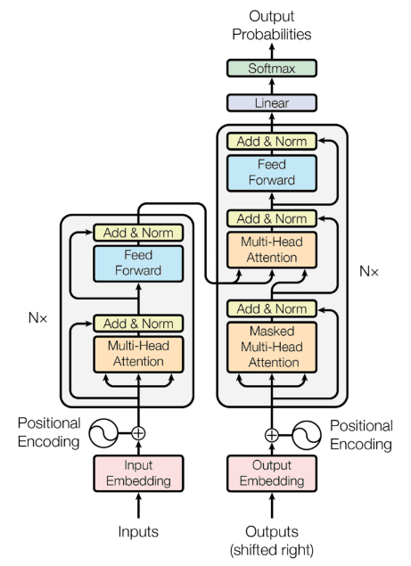
Figure 4 Transformer Architecture.

Encoder: Word embeddings are dense vector representations of words that capture the semantic and syntactic relationships between words. Inbuild embedding functionality is provided by tensorflow keras module. Encoding vector size is assigned as 128 dimensions in the model. Next, Positional encoding class is coded, which is a simple trigonometric formula capable of capturing information related to relative positioning of each word. This is required in transformer which lacks sequential RNNs. Multi-head attention block, the self-attention layer, allows to capture the relation between different words. Multi-head allows parallel handling of projections so that different sections of the sentences can be self-attended at the same time. The number of projections in the model are configured as 8. After that, Normalization and Dropout is done to prevent overfitting. Final model uses dropout rate of 0.1. 2 FFN layers are implemented with relu activation function, connected by 512 neurons. Final step is dropout and normalization again.
Decoder: It has 2 multi-head attention blocks. 1st multi-head attention block is for self-attention of actual translation. The 2nd one is for encoder-decoder attention, as it takes final output of Encoder to attend to its different positions. FFN network in decoder uses the same configurations as encoder to produce the normalized output.
The decoder output is fed to a dense layer to produce vector with vocabulary size. The softmax function at the end calculates the probability of each word in vocabulary to have a representation in the final output vector. The model had 4 layers of Encoder and Decoder each. Sparse Categorical Cross Entropy was used as loss function. The model was trained for 30 epochs with each epoch having 200 batches of input. This is all about the implementation details of the model.
IV. Results and Discussions
BLEU (Bilingual Evaluation Understudy) [23] score is a metric used to rate the quality of machine-translation output. It measures the similarity between a machine-generated translation and one or more reference translations provided by humans. The BLEU score ranges from 0 to 1, with 1 indicating a perfect match between the machine translation and the reference translations. Generally, a higher BLEU score indicates a higher quality translation. Since BLEU is fairly simple to calculate, we are using this score as the metric to compare our models in terms of quality for both way translations.
Since the model is trained on sentences lesser than 20 words in source language, the validation data also contained sentences with 20 or less words. The average BLUE score was calculated for 2 validation datasets. The first set is taken from the Europarl corpus from the lines immediately after the training dataset i.e., line number 5,00,001. The second dataset is taken from the very end of Europarl corpus. The first dataset was closest to training data while the second dataset was farthest from the training data within the available corpus. Therefore, first validation dataset was having more similar vocabulary of words as in training dataset as compared to the second dataset.
A. English to German Translation
For English to German translator, the average BLUE score for 16 unseen sentences taken immediately after the training data from Europarl corpus was 0.47. The average BLUE score calculated for 12 unseen sentences taken from the end of the corpus, which are farthest from the training data, was 0.30.
Figure 5 shows the Training Accuracy vs Epoch plot and the Training Loss vs Epoch plot for the model.
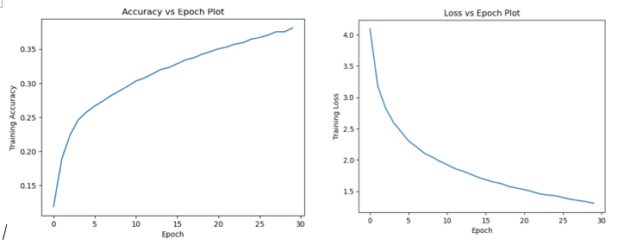
Figure 5 Accuracy/ Loss vs Epoch plot for EN-DE Translator model.
Table 2 shows few examples of EN to DE Translations done by the model.
Origin Sentence (En) | Model Translation (De) | Actual Translation (De)
The commission has rejected the proposal | Die Kommission hat den Vorschlag abgelehnt | Der Antrag des Rechnungshof und abgelehnt
The vote will be tomorrow at 1030 am | Die Abstimmung findet morgen um 1030 Uhr statt | Die Abstimmung findet morgen um 1130 Uhr statt
Table 2 English to German translations performed by model.
B. German to English Translation
For German to English translator, the average BLUE score for 18 unseen sentences taken immediately after the training data from Europarl corpus is 0.42. The average BLUE score calculated for 15 unseen sentences taken from the end of the corpus, which are farthest from the training data, was 0.36.
Figure 6 shows the Training Accuracy vs Epoch plot and the Training Loss vs Epoch plot for the model.

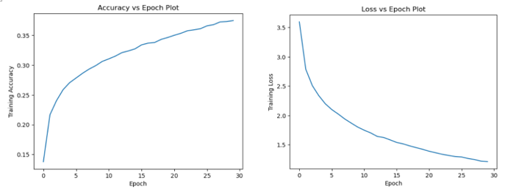
Figure 6 Accuracy/ Loss vs Epoch plot for DE-EN Translator model.
Table 3 shows few examples of DE to EN Translations done by the model.
Origin Sentence (En) | Model Translation (De) | Actual Translation (De)
Die Kommission hat den Vorschlag abgelehnt | The commission has rejected the proposal | The Commission rejected the Commission proposal
Es geht einfach darum, ja oder nein zu sagen. | In this case it is a question of saying yes or no | It is a question is not really is not just now, but no answer
Table 3 German to English translations performed by model.

BLUE score for first dataset which is closer to training data in corpus has better average than farther dataset 2. This shows that translation quality will be affected with the kind of words in the input sentence. Also, as length of the sentence increases, the quality of translation will go down.
Both Figure 3 and Figure 4 i.e., Accuracy and Loss plots for both the models are plotted for 30 epochs for which model was trained. The training took around 3 hours each to complete. As seen from the plots, the Accuracy was still improving and Loss was still reducing till the end. It indicates that with more epochs and training, the performance of model can be further improved a lot. Other Hyperparameters like Number of Encoder/decoder layers or number of FFN units or the optimizer, etc also can be further tuned to give better accuracy and translations.
V. Conclusions
Starting from Literature Survey phase till the final stage of executing and testing the model, there were several learnings made from the whole process, especially while resolving the different challenges encountered at several steps. Being a hot topic, there is vast amount of latest research work available in this domain. Transformer based models are first introduced in 2017, so it is not very old concept. After understanding the theory part, the implementation part was started with EDA. Handling huge amount of data was a challenge because of the availability of very limited resources, so we filtered out the most suitable data possible, as described in section III(A). Base model, which was RNN based, gave a good glimpse on the basics of coding encoder layer, Attention layer and decoder layer and connecting them all. Base model gave average BLUE score of 0.11 over 15 sentences. The poor quality was noticed from the frequent repetitions of similar words in the output sentence. It was a simple model just to get the process started.
Then, we experimented with several variations over the base model like variations in training dataset, tuning the hyperparameters as well as changing the model architecture. We tried two type of Attention mechanism: Luong’s Attention and Cross attention and there was significant improvement in performance after switching to cross attention. Then, we finally started with the Transformer based model implementation. First step was to code different building blocks of Encoder and Decoder layers. After that, we connected them and run the iterations multiple times by changing in the hyper-parameter values. We learnt that changing in hyper-parameter not only helped in improving accuracy but also optimizing the training time as well.
Ultimately, we were able to build a working model for way translations. With sufficient training, the same model can be trained to provide a lot better translation quality. We have a decent understanding now how the Deep Learning is playing a significant role in current NLP problems. Machine Translation is definitely a significant contribution of Deep learning in this domain and with the continuous research and development being done in this area to improve the quality, the linguistic barrier can be removed to connect the people all over the world.
References
- Eberhard, David M., Gary F. Simons, and Charles D. Fennig (eds.). 2023. Ethnologue: Languages of the World. Twenty-sixth edition. Dallas, Texas: SIL International.
- Census of India – Language Atlas (2011), Primary Census Abstracts, Registrar General of India, Ministry of Home Affairs, Government of India.
- Andrews, Carol AR. The Rosetta Stone. London: British Museum Publications, 1981.
- Hutchins WJ. Machine translation: A brief history. In Concise history of the language sciences 1995 Jan 1 (pp. 431-445). Pergamon.
- Poibeau, Thierry. Machine translation. MIT Press, 2017.
- Slocum, Jonathan. "A survey of machine translation: Its history, current status and future prospects." Computational linguistics 11.1 (1985): 4-10.
- Koehn, P., Knight, K.: Empirical Methods for Compound Splitting. In: Proc. 10th Conf. of the European Chapter of the Association for Computational Linguistics (EACL), Budapest, Hungary, pp. 347–354 (2003).
- Zhang J, Zong C. Neural machine translation: Challenges, progress and future. Science China Technological Sciences. 2020 Oct;63(10):2028-50.
- Popović, Maja, Daniel Stein, and Hermann Ney. "Statistical machine translation of German compound words." Advances in Natural Language Processing: 5th International Conference on NLP, FinTAL 2006 Turku, Finland, August 23-25, 2006 Proceedings.
- Brown, Peter F., et al. "A statistical approach to machine translation." Computational linguistics 16.2 (1990): 79-85.
- Kalchbrenner, N. and Blunsom, P. (2013). Recurrent continuous translation models. In Proceedings of the ACL Conference on Empirical Methods in Natural Language Processing (EMNLP), pages 1700–1709. Association for Computational Linguistics
- Yonghui Wu, Mike Schuster, Zhifeng Chen, Quoc V. Le, Mohammad Norouzi, Wolfgang Macherey, Maxim Krikun, Yuan Cao, Qin Gao, Klaus Macherey, Jeff Klingner, Apurva Shah, Melvin Johnson, Xiaobing Liu, Łukasz Kaiser, Stephan Gouws, Yoshikiyo Kato, Taku Kudo, Hideto Kazawa, Keith Stevens, George Kurian, Nishant Patil, Wei Wang, Cliff Young, Jason Smith, Jason Riesa, Alex Rudnick, Oriol Vinyals, Greg Corrado, Macduff Hughes, Jeffrey Dean. “Google’s Neural Machine Translation System: Bridging the Gap between Human and Machine Translation.” (2016).
- Quoc V. Le & Mike Schuster, Research Scientists, Google Brain Team. “A Neural Network for Machine Translation, at Production Scale.” (2016).
- Bahdanau, Dzmitry, Kyunghyun Cho, and Yoshua Bengio. "Neural machine translation by jointly learning to align and translate." arXiv preprint arXiv:1409.0473 (2014).
- Sutskever, I., Vinyals, O., and Le, Q. (2014). “Sequence to sequence learning with neural networks. In Advances in Neural Information Processing Systems.” (NIPS 2014).
- Cho, K., van Merrienboer, B., Gulcehre, C., Bougares, F., Schwenk, H., and Bengio, Y. “Learning phrase representations using RNN encoder-decoder for statistical machine translation. In Proceedings of the Empiricial Methods in Natural Language Processing (EMNLP 2014). to appear.” (2014).
- Vaswani, Ashish, et al. "Attention is all you need." Advances in neural information processing systems 30 (2017).
- Mikolov, Tomas, Quoc V. Le, and Ilya Sutskever. "Exploiting similarities among languages for machine translation." arXiv preprint arXiv:1309.4168 (2013).
- 2011. Proceedings of the Sixth Workshop on Statistical Machine Translation. Association for Computational Linguistics, USA.
- Mikolov, Tomas, et al. "Efficient estimation of word representations in vector space." arXiv preprint arXiv:1301.3781 (2013)
- Devlin, Jacob et al. “BERT: Pre-training of Deep Bidirectional Transformers for Language Understanding.” ArXiv abs/1810.04805 (2019).
- Zhu, Jinhua, et al. "Incorporating bert into neural machine translation." arXiv preprint arXiv:2002.06823 (2020).
- Papineni, Kishore, et al. "Bleu: a method for automatic evaluation of machine translation." Proceedings of the 40th annual meeting of the Association for Computational Linguistics. 2002.
- Europarl: A Parallel Corpus for Statistical Machine Translation, Philipp Koehn, MT Summit 2005.
- Zhang Y, Liu G. Paragraph-parallel based neural machine translation model with hierarchical attention. InJournal of Physics: Conference Series 2020 (Vol. 1453, No. 1, p. 012006). IOP Publishing. 2. Cho, K., Van Merri ̈enboer, B., Bahdanau, D., Bengio, Y.: On the proper-ties of neural machine translation: Encoder-decoder approaches. arXiv preprintarXiv:1409.1259 (2014).

